**Polygons A**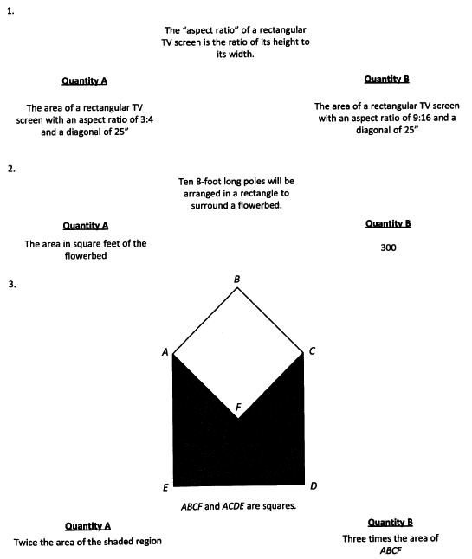

**Polygons B** 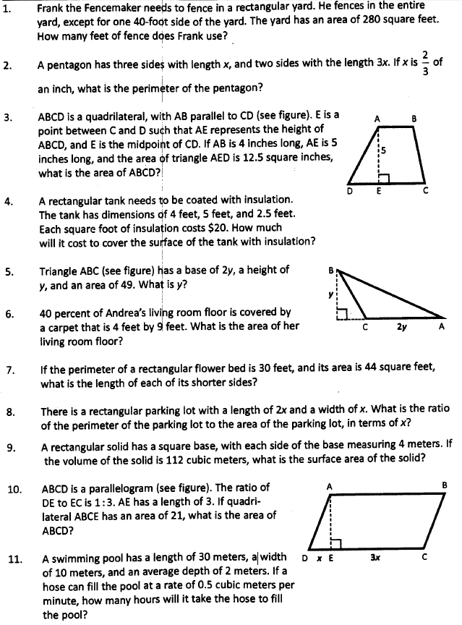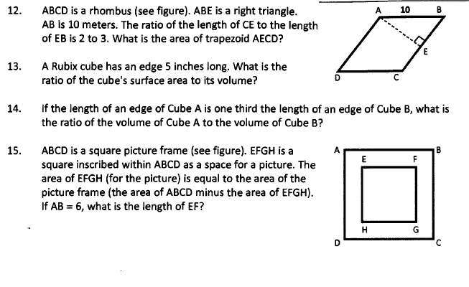

**Triangles A**

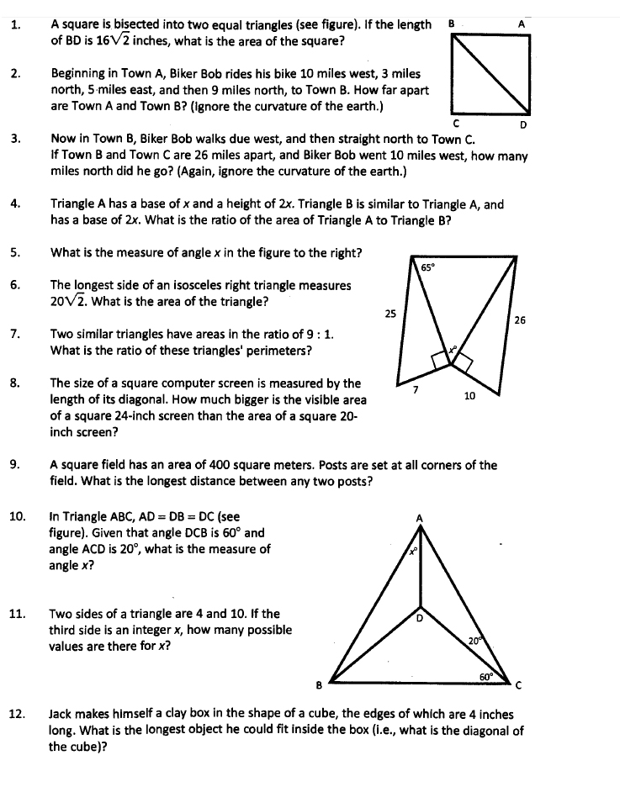

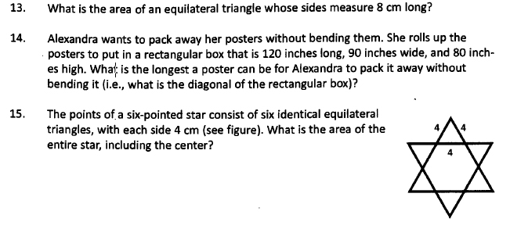

**Triangles B**

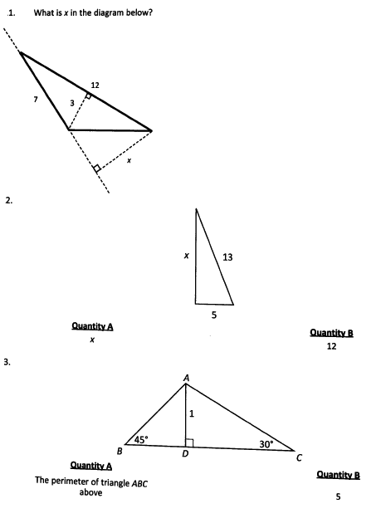

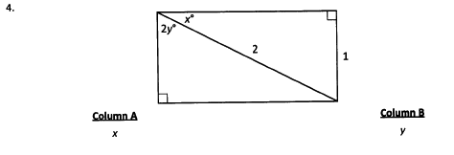

**Miscellaneous Questions**

1. Two sides of a triangle have length 6 and 8. Which of the following are possible areas of the triangle? Indicate all possible values
2. 2
3. 12
4. 24
5. If a right triangle has area 28 and hypotenuse 12, what is its perimeter?

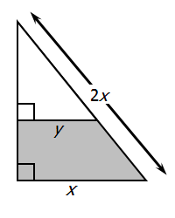

1. For the figure above, in terms of x and y, what is the area of the shaded region?

Note: Figure not drawn to scale

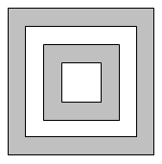

1. In the figure above, if the areas of the 4 squares are 50, 32, 18 and 12, what is the ratio of the small shaded portion to the area of the large shaded portion?

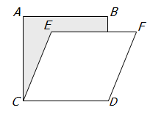

1. For the figure above, if ABCD is a square with area 625, and CEFD is a rhombus with area 500, then the area of the shaded region is

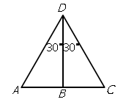

1. Please refer to the figure above

Column A: AB

Column B: BC

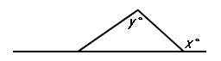

1. Column A: x

Column B: y

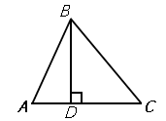

1. Column A: BD/AB

Column B: BC/DC

1. If x>0, and two sides of a certain triangle have lengths 2x+1 and 3x+4 respectively, which of the following could be the length of the third side of the triangle? Indicate all possible lengths.
2. 4x+5
3. x+2
4. 6x+1
5. 5x+6
6. 2x+17
7. If the length and width of rectangle R are each increased by 1, the area of the new rectangle will be 72. If the length and width of rectangle R are each decreased by 1, the area of the new rectangle will be 35. What is the perimeter of rectangle R? 37

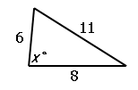

1. Column A: x

Column B: 90

